Q.1) Convert given hrs & mins in second

hour=int(input("Enter hours: "))

min=int(input("Enter minutes: "))

sec=(hour*3600)+(min*60)

print(hour,"hours and ",min,"minutes are total ",sec, "seconds.")

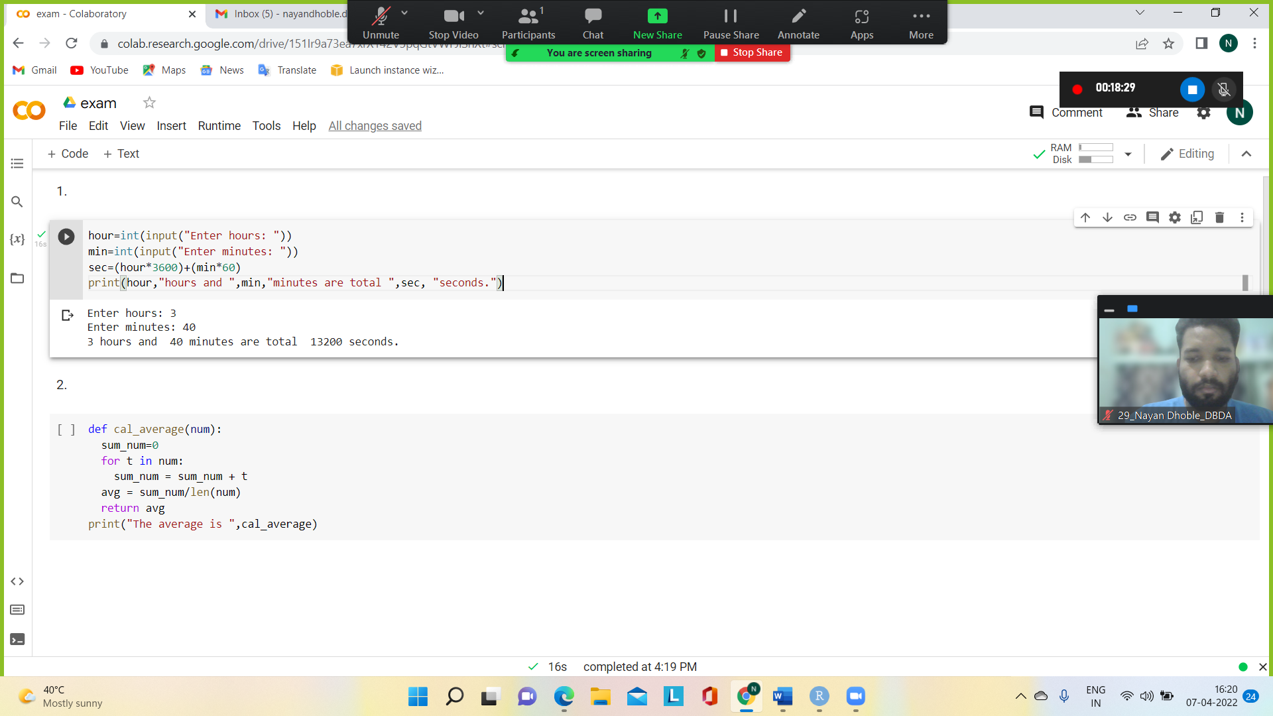

Q.3) Print

for i in range (1,6):

  for j in range(1,i+1):

    print(j%2,end=" ")

  print()

Q.5) Create class

class Math:

  def __init__(self,a,b):

    self.a=a

    self.b=b

  def Add(self):

    return self.a+self.b

  def Sub(self):

    return self.a-self.b

  def Multiple(self):

    return self.a*self.b

  def Division(self):

    return self.a/self.b

m=Math(20,4)

print(m.Add())

print(m.Sub())

print(m.Multiple())

print(m.Division())

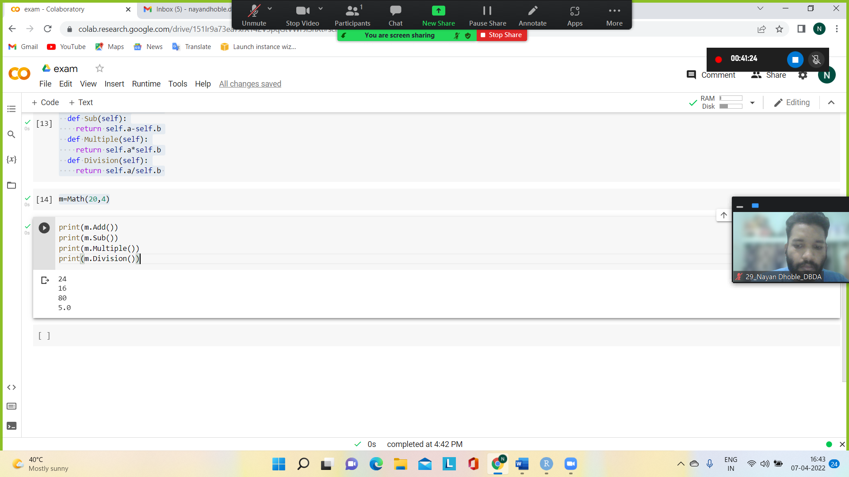

Q.6) Read file & count numbers of digit alphabets & symbols (hint one can compare using ‘a’ < digit < ‘z‘.

a= input("Enter a string: ")

d=l=s=0

for i in a:

  if i.isdigit():

    d=d+1

  elif i.isalpha():

    l=l+1

  else:

    s=s+1

  print("Letters: ",l)

  print("Digits: ",d)

  print("symbol: ",s)

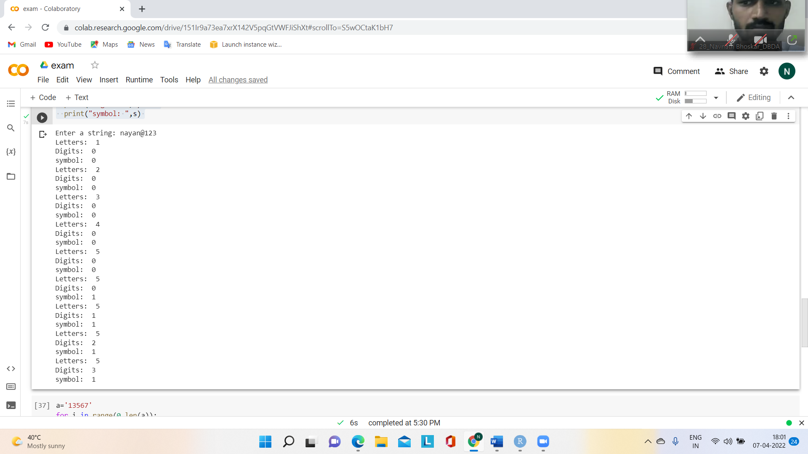

Q.8) Print

a='13567'

for i in range(0,len(a)):

  print(a[i]*(i+1),)

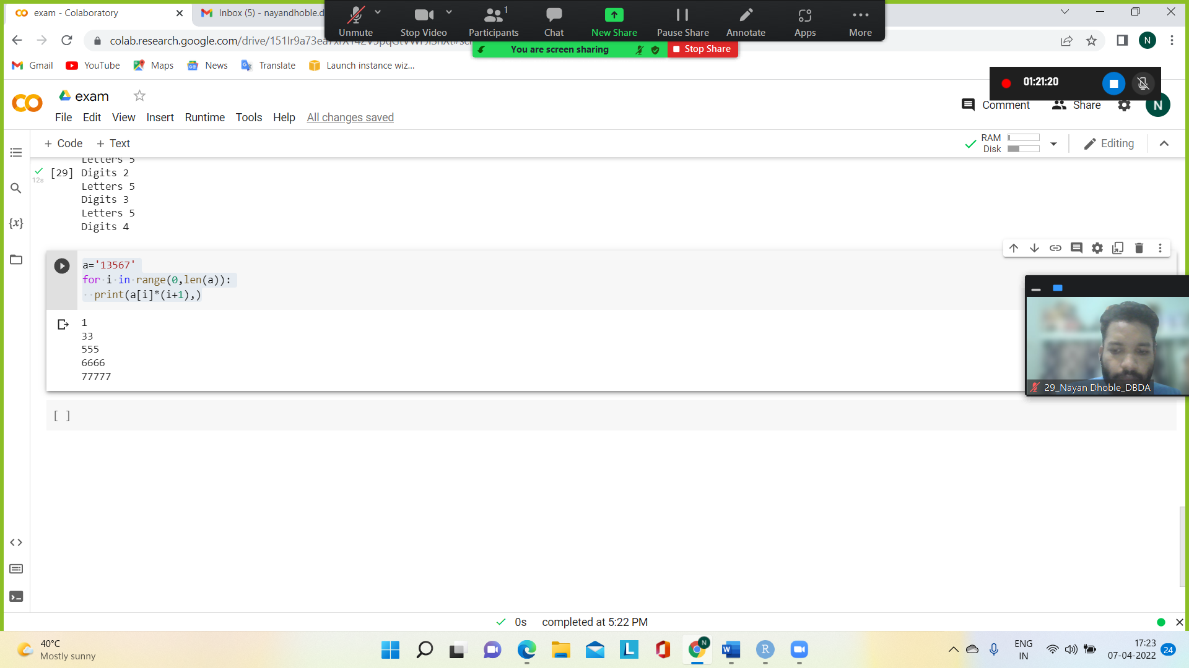

Q.10) Create menu driven code for 1) Accept 2 numbers 2) Add 3) Sub 4) Mul 5) Div

num1=float(input("Enter first number: "))

num2=float(input("Enter second number: "))

print("Enter which operation to perform?")

ch=input("Entyer the specific operations +<-,*,/ :")

result=0

if ch =='+':

  result = num1+num2

elif ch == '-':

  result = num1-num2

elif ch == '*':

  result = num1*num2

elif ch == '/':

  result = num1/num2

else:

  print("Invalid input")

print(num1, ch, num2, ':',result)

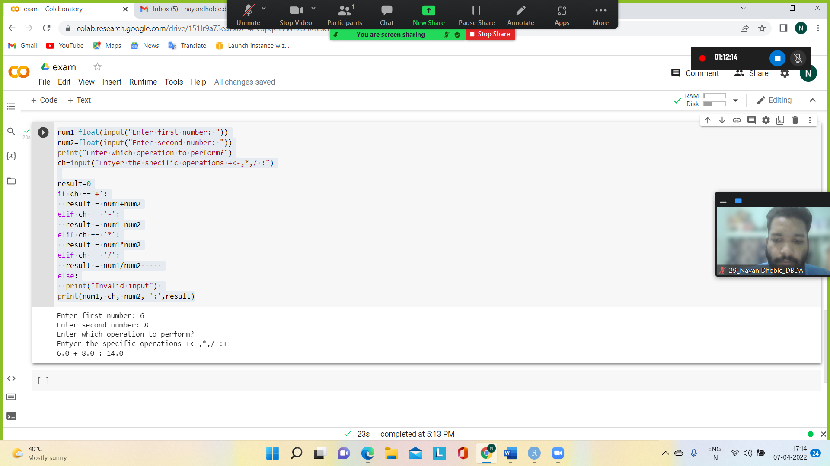

R.programming

1.

print("Sequence of numbers from 20 to 50:")

print(seq(20,50))

print("Mean of numbers from 20 to 60:")

print(mean(20:60))

print("Sum of number from 51 to 91: ")

print(sum(51:91))

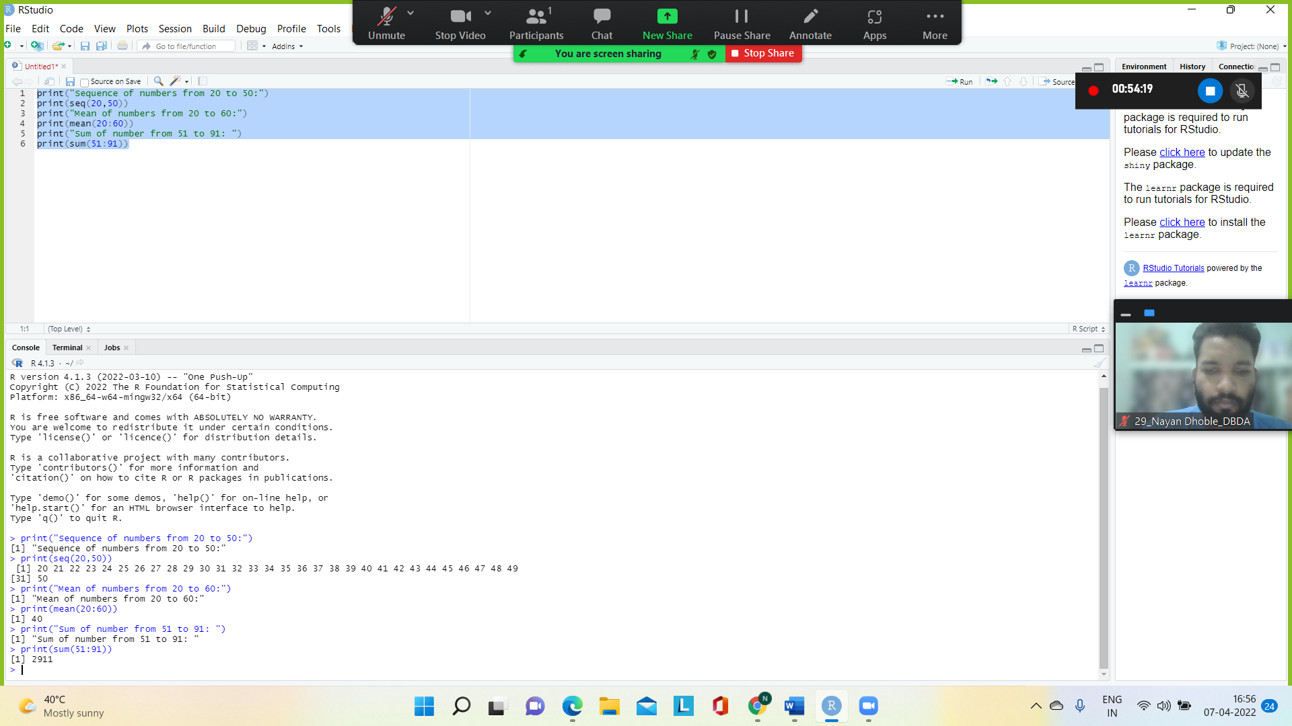

2.

for (n in 1:100) {

if (n%%3 == 0 & n %% 5 == 0) {print("FizzBuzz")}

else if (n %% 3 ==0) {print("FizzBuzz")}

else if (n %% 5 == 0) {print("Buzz")}

else print(n)

}

